**Front End – Back End Integration.**

In order to check react based front end application works with node based back end application;

BEFORE WE PROCEED:

run ***npm install*** to update and get node_modules downloaded on the machine for both the projects as node_modules folder is not checked in to the GITHUB repository

Let us start by checking what mongo DB has.

1. Open command prompt.
2. Run mongo.exe on command prompt.

**C:\Program Files\MongoDB\Server\8.0\bin>mongo.exe**

1. Switch to “movies DB” using command:

**use moviesdb**

1. Check that data exists in various collections that we have created using:

**db.users.find().pretty()**

**db.movies.find().pretty()**

**db.genres.find().pretty()**

**db.artists.find().pretty()**

Let us ensure the node application is working and is capable to establish a connection with Mongo DB.

1. Open Node project in VS Code.
2. Ensure that in the file server.js

* PORT No is specified.
* It can be any unused and legal port number
* We are going to use PORT 8085 for Node app to work
* Ensure that CORS policy is specified as it will allow us to get / send data from react application – which is going to get considered as – another domain / origin itself.
* Normally JS calls from different domain are by default blocked by receiver side so it’s better to specify CORS policy.

1. Open Node folder using command prompt
2. Type below command to start Node Server:

**Node server.js**

1. Above command will start node server.js which is more of an entry point for node application.
2. After running this application; if no errors appear on command prompt;

* Open browser
* Try testing few GET request calls like:
* **http://localhost:8085/api/movies**

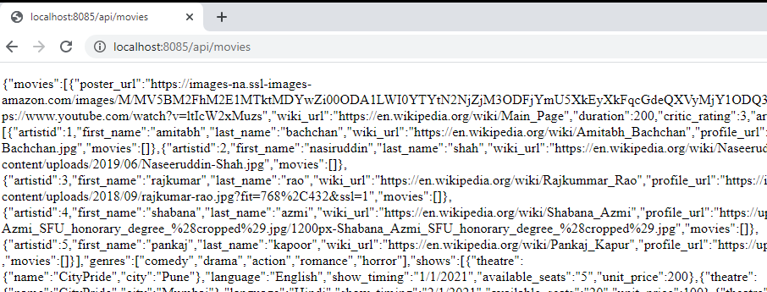

* **http://localhost:8085/api/movies/1**

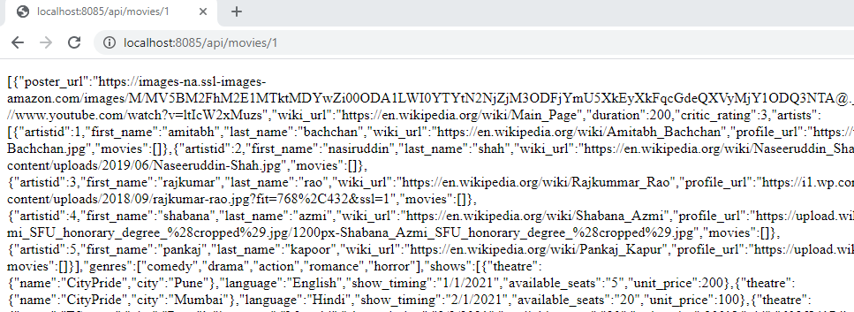

* [**http://localhost:8085/api/movies?status=PUBLISHED**](http://localhost:8085/api/movies?status=PUBLISHED)

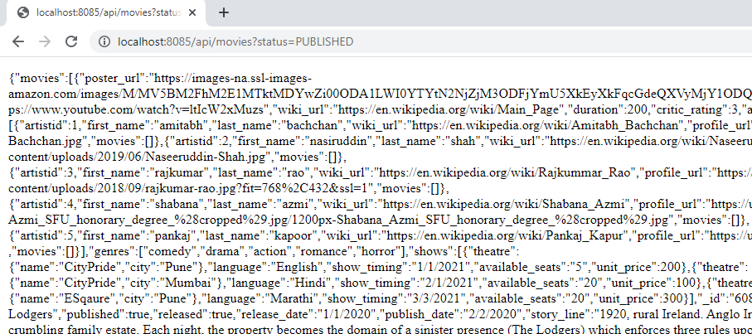

* [**http://localhost:8085/api/genres**](http://localhost:8085/api/genres)

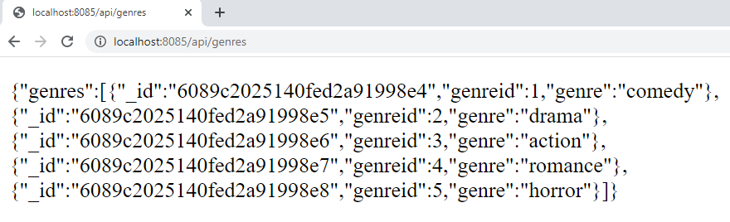

* [**http://localhost:8085/api/artists**](http://localhost:8085/api/artists)

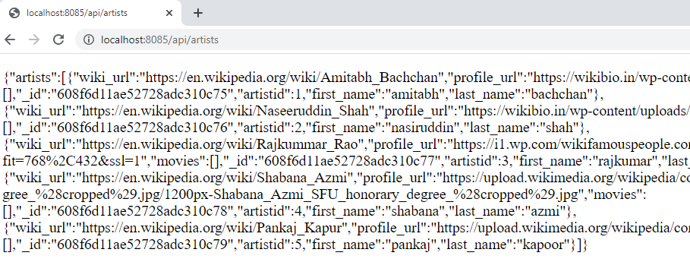

Now, as basic API URLs are already checked; open REACT application code in VS Code

1. So, Open REACT project in VS Code i.e. ***movies-app-master*** project
   1. Open “App.js” file
   2. Change the baseUrl value to <http://localhost:8085/api/>
   3. React application will be running on 3000 port number
   4. React application will give AJAX calls to Node application running on 8085 PORT number
   5. Open Home.js file.
   6. Ensure that every **axios Request** refers to a valid link.
   7. Run react application from command prompt by using:

**npm start**

* 1. Default page will bring UI like:

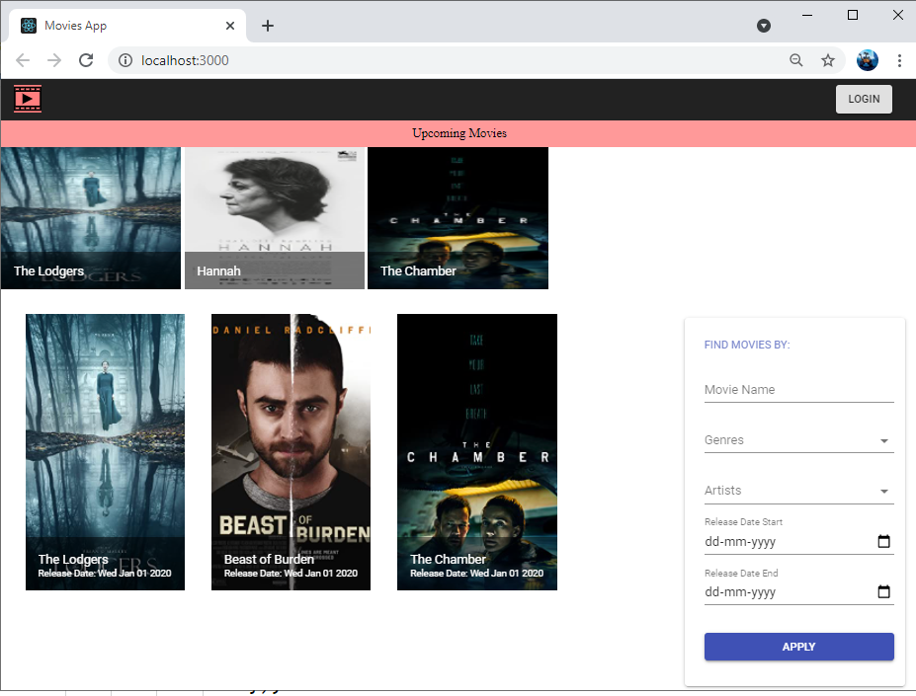

1. Searching in the right side pallet will bring filtered data on UI like:

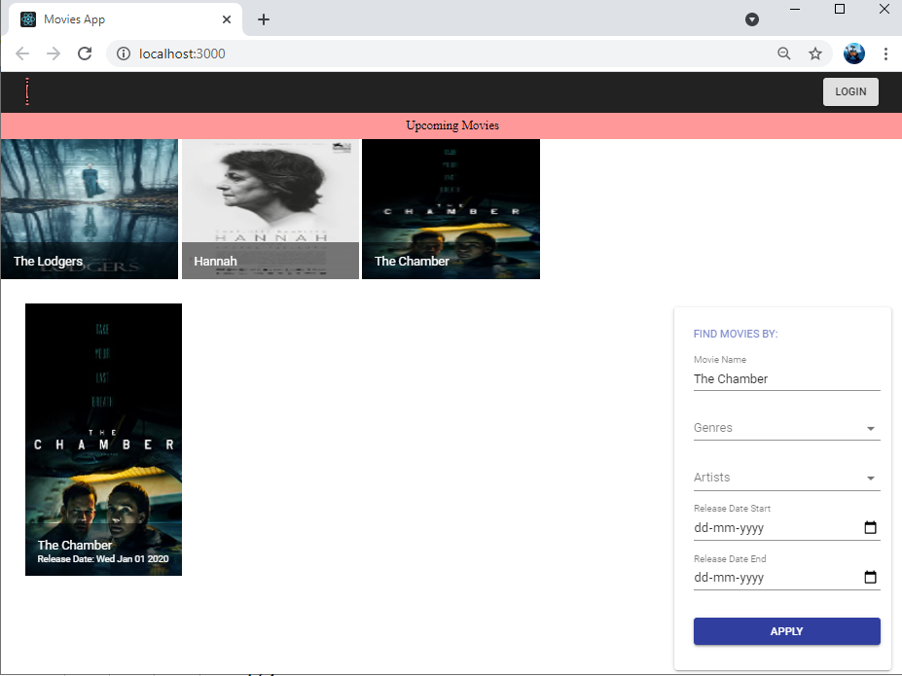

1. Clicking on the movie image; will bring details page on the screen like:

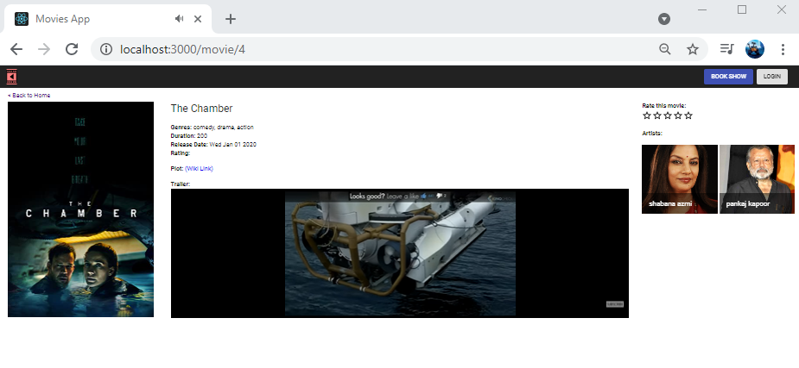

1. Clicking on artist’s image; will take you to Wikipedia link